Respected sir/madam,
I take this opportunity to introduce myself and to make you familiar with my accomplishment and expertise. I have completed my masters in computer science and management from Barkatullah University Bhopal, recently I have working with some top MNCS like TRIMBLE Mexico USA, GEOMAX POSITIONING (PART OF HEXAGON) SWITZERLAND and FOIF GROUP CHINA (under the authorized company for India) FOR MADHYA PRADESH AND CHATTISHGARH on his particular brand as a BRANCH HEAD for same area in both groups as well as corporate level marketing (b2b) and (c2b).
My curriculum vitae which are attached contains additional information on my skills I would appreciate the opportunity to provide further information on my candidacy.
I hope my curriculum vitae fit the available opening in your esteemed organization .i look forward hear from you soon ,I can be reached through my cell phone or email id mentioned below.
Thank you for your time and consideration

With warm regard
Akhilesh K. Shukla
09424328821
Akhileshshukla1@outlook.com

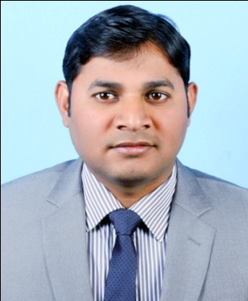

Akhilesh Kumar Shukla
9424328821
akhilesh@geosystemsindia.com
Career Objective:
Aspiring for a position in an organization, which will enable me to utilize my analytical skills and abilities that offers responsibilities while being innovative and effectively contributing towards the goals of the organization.
Brief overview
- Core business of team management
- Comprehensive experience in business development for retail products.
- Well versed with customer service and satisfaction.
- Build natural relationship with customer for future business.
- Create macro environment for business to business relationship.
Work Experience: professional 10year

Organization: Geosystems allterra technologies llp
Duration: January 2013 to Till Date…
Designation: Branch head (mp &Chhattisgarh)
Roles and Responsibilities:
- Responsible for the direct as well as channel sales activities.
- Identify customers need using need analysis method and offer the remote sensing equipment according there need.
- Recruit and develop the team of sales personnel and ensure there induction, training and skill development.
- Ensure that teams have clarity and understanding on products, process, documentation and procedure for smoothly performing daily duties.
- Driving the team for field activities data collection, lead generation and prospect building on daily basis.
- Driving them for common task assigned.
- Build customer relationship based on trust.
- Coordinating with Dealers regarding retail business of products.
- Prepare, present daily reports and maintaining MIS.
- Working with on the roles of I-Process.
Training Attended:
- Handling remote sensing equipment
- Basic understanding on SAP.
Achievement:
- 3rd runner up best sales person of the year 2014.
Skills Acquired:
- Handling real time work pressure.
- Adaptability
- Convincing and build relationship.
- Networking.

Duration: November2011 to January 2013
Designation: sales executive (mp & Chhattisgarh)
Roles and Responsibilities:
- Taking initiatives in events or extra activities for more business
- Managing relations & generating leads through presentations in companies
- Enhancing the business through retail individuals of cream profile
- Relationship management, managing builders and generating leads.
Training Attended:
- Demonstration and presentation of equipments.
- Basic understanding on geotechnical equipment.
Achievement:
- Best sales person of the year 2012.
Skills Acquired:
- Available data gathering and capturing power.
- Handling real field problem.
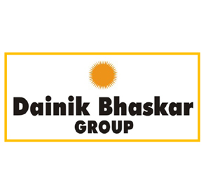
Organization: Bhaskar denim fabric (P) Ltd
Duration: June 2011 to November 2011
Designation: marketing executive
Roles and Responsibilities:
- Contact to new client for better business relationship.
- To provide the quality knowledge of our product in commercial market.
- Analysis of inventory variance & maintenance of stock as per records (SAP).
- Track the existing distributor.
Training Attended:
- Presentation of fabric.
- Basic understanding of sales.
Skills Acquired:
- Available data gathering and capturing power.
- Handling real field problem.
Academic qualification:
- MBA from Barkatullah university on marketing on the year of 2010 to 2012.
- M.Sc. (CS)LE makhanlal chaturvedi national patrakarita university (M.P.) 2008-2010.
- B.com from Awadhesh pratap singh university Rewa (M.P.) in the session 2004-2009.

Extra curriculum activity:
- GOVERNER AWARDED FROM BHARAT SCOUT AND GUIDE PROVIDED IN THE YEAR OF 2004.
- PLAYING CRICKET OF UNIVERSITY LEVEL CHAMPIANSHIP BY APS UNIVERSITY REWA IN THE YEAR OF 2007.
- PARTICIPATE OF IN INDEPENDENCE DAY AND REPUBLIC DAY PARED IN THE YEAR OF 2000 TO 2004.
- PARTICIPATE IN OTHER CULTURAL ACTIVITY IN SCHOOL AND COLLEGE LEVEL.
Computer skill:
- Proficiently use. 
- internet portals like. 

Declaration:
I hereby declare that information furnished in my resume is true to the best of my knowledge and belief.

Date: 07/12/2021 SIGNATURE
Place: Bhopal(M.P) Akhilesh Kumar Shukla

